1st page:
NUCLEAR ENERGY
Nuclear energy is a form of energy released from the nucleus, the core of atoms, made up of protons and neutrons. This source of energy can be produced in two ways: fission – when nuclei of atoms split into several parts – or fusion – when nuclei fuse together.
The nuclear energy harnessed around the world today to produce electricity is through nuclear fission, while technology to generate electricity from fusion is at the research and development phase.
2nd page:
IMPORTANCE OF NUCLEAR ENERGY:
1) Nuclear power and hydropower form the backbone of low-carbon electricity generation. Together, they provide three-quarters of global low-carbon generation. Over the past 50 years, the use of nuclear power has reduced CO2 emissions by over 60 gigatonnes – nearly two years’ worth of global energy-related emissions. Nuclear power is the second-largest source of low-carbon electricity today.
2) Alongside renewables, energy efficiency and other innovative technologies, nuclear can make a significant contribution to achieving sustainable energy goals and enhancing energy security.
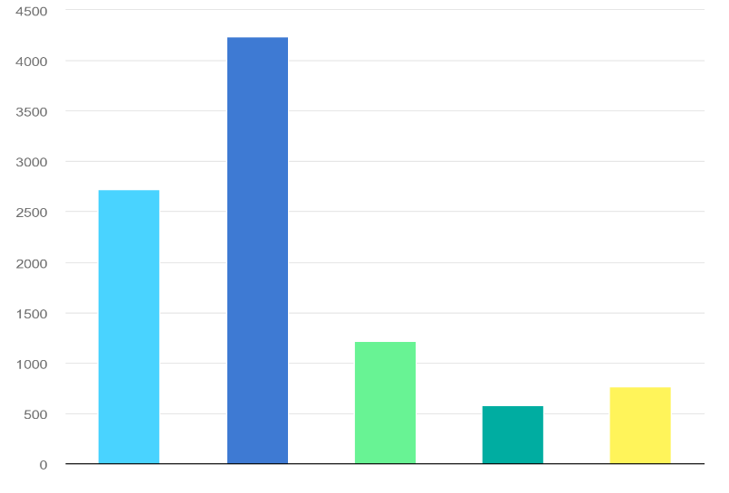
3.HISTORY OF NUCLEAR ENERGY:
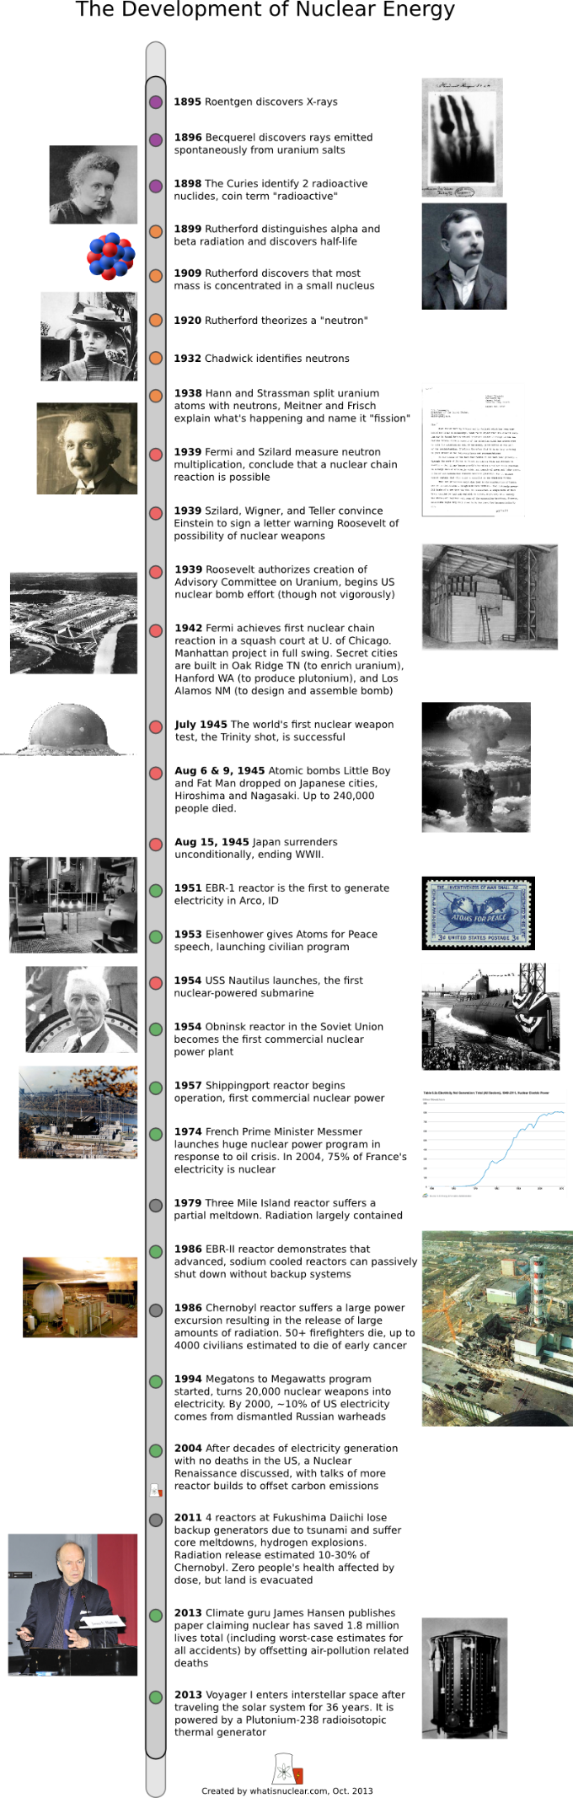
3)Basic terms of nuclear energy:
Sure, here are some basic terms related to nuclear science:

1. *Nucleus:* The central part of an atom, composed of protons and neutrons.

2. *Atom:* The basic unit of matter, consisting of a nucleus and electrons orbiting around it.

3. *Proton:* A positively charged particle found in the nucleus of an atom.
4. *Neutron:* A particle with no electric charge found in the nucleus of an atom.

5. *Electron:* A negatively charged particle orbiting the nucleus of an atom.

6. *Isotope:* Atoms of the same element with different numbers of neutrons, leading to different atomic masses.

7. *Radioactivity:* The spontaneous emission of radiation from the nucleus of an unstable atom.

8. *Half-life:* The time it takes for half of the atoms in a radioactive substance to decay.

9. *Alpha Particle:* A type of ionizing radiation consisting of two protons and two neutrons, emitted during certain types of radioactive decay.

10. *Beta Particle:* A type of ionizing radiation consisting of electrons (beta-minus) or positrons (beta-plus), emitted during radioactive decay.

11. *Gamma Ray:* High-energy electromagnetic radiation emitted from the nucleus during radioactive decay.

12. *Fission:* The splitting of an atomic nucleus into two smaller nuclei, releasing a large amount of energy.

13. *Fusion:* The process of combining two light atomic nuclei to form a heavier nucleus, releasing a tremendous amount of energy.

14. *Chain Reaction:* A self-sustaining series of nuclear fission reactions, producing a significant release of energy.

15. *Critical Mass:* The minimum amount of fissile material required to sustain a nuclear chain reaction.

16. *Nuclear Reactor:* A facility where controlled nuclear reactions take place, often used for generating electricity.

17. *Nuclear Power:* The use of nuclear reactions to generate heat, which is then converted into electricity.

18. *Nuclear Waste:* Radioactive byproducts generated from nuclear reactions, requiring safe storage and disposal.
19. *Radiation:* The emission of energy as particles or electromagnetic waves from the nucleus of an atom.
20. *Radioactive Decay:* The process in which an unstable atomic nucleus transforms into a more stable configuration by emitting radiation.
4)APPLICATION OF NUCLEAR ENERGY:
Hydrogen production:
Nuclear energy can assist in hydrogen production through a process called electrolysis. By using nuclear-generated electricity, electrolysis can split water into hydrogen and oxygen.
Seawater Desalination:
Nuclear reactors produce a substantial amount of heat, which can be used to generate steam that drives desalination processes like multi-effect distillation or reverse osmosis. This helps convert seawater into freshwater, addressing water scarcity issues in regions with limited access to clean water sources.
District and process heat:
Nuclear reactors produce a significant amount of heat as a byproduct of generating electricity. This excess heat can be efficiently utilized to provide heating for residential, commercial, and industrial purposes. Cogeneration systems can distribute the heat generated by nuclear reactors to nearby communities, reducing the reliance on fossil fuels and contributing to more sustainable and eco-friendly heat production.
Synthetic fuels and chemicals:
Nuclear energy can play a role in the production of nuclear fuels and certain chemicals through processes like nuclear transmutation. Nuclear reactors can be used to irradiate certain materials, transforming them into isotopes that are useful for nuclear fuel production or medical applications.
Cooling and refrigeration application:
Nuclear energy can contribute to cooling and refrigeration applications through the concept of cogeneration or combined heat and power (CHP). Nuclear reactors generate a substantial amount of heat as they produce electricity. This excess heat can be repurposed for cooling or refrigeration processes, such as air conditioning, industrial cooling, or refrigerated storage.

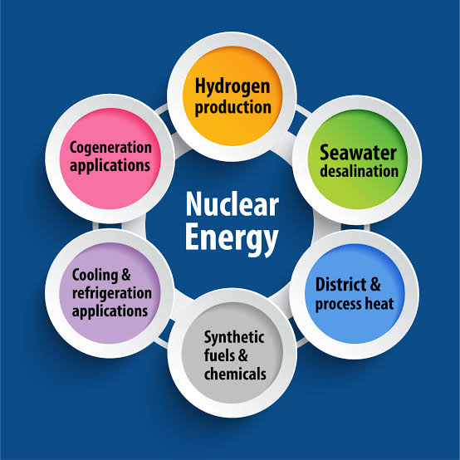
Advantages and Disadvantages of nuclear energy:
- Carbon Free Electricity:
While traditional fossil fuel generation sources pump massive amounts of carbon dioxide (the primary cause of global climate change) into the atmosphere, nuclear energy plants do not produce carbon dioxide, or any air pollution, during operation.

Small land footprint:

Compared to other common clean energy facilities (particularly wind and solar power), nuclear energy plants take up far less physical space. According to the Department of Energy, a typical nuclear facility producing 1,000 megawatts (MW) of electricity takes up about one square mile of space.

High power output:

Nuclear power plants produce high levels of energy compared to most power sources (especially renewables), which makes them a great provider of baseload electricity. Nuclear has the potential to be this high-output baseload source. Additionally, nuclear is a prime candidate for replacing current baseload electricity sources that contribute significantly to air pollution, such as large coal plants.

Reliable energy source:

Lastly, nuclear energy is a reliable renewable energy source based on it’s constant production and accessibility. Nuclear power plants produce at their maximum power output more often (93% of the time) than any other energy source, and because of this round-the-clock stability, this makes nuclear energy an ideal source for reliable baseload electricity for the grid.

Disadvantage of nuclear energy:

Uranium is non-renewable:
Although nuclear energy is a “clean” source of power, it is technically not renewable. Current nuclear technology relies on uranium ore for fuel, which exists in limited amounts in the earth’s crust. The longer we rely on nuclear power (and uranium ore in particular) the more depleted the earth’s uranium resources will become, which will drive up the cost of extracting it, as well as the negative environmental impacts from mining and processing the uranium.

High upfront costs:
Operating a nuclear energy plant is a relatively low-cost endeavor, but building it in the first place is very expensive. Nuclear reactors are complex devices that require many levels of safety built around them, which drives up the cost of new nuclear plants.

Nuclear waste:
Nuclear waste is a complicated issue, and we won't claim to be anything near experts. Nuclear waste is radioactive, making it an environmental and health catastrophe waiting to happen. These reasons are exactly why governments spend tons of money to safely package up and dispose of used-up nuclear fuel.

Malfunctions can be catastrophic:
A nuclear meltdown occurs when the heat created by a nuclear reactor exceeds the amount of heat being transferred out by the cooling systems; this causes the system to exceed its melting point. If this happens, hot radioactive vapours can escape, which can cause nuclear plants to fully melt down and combust, while also releasing harmful radioactive materials into the environment. This is a worst-case-scenario that is extremely unlikely, and nuclear plants are equipped with numerous safety measures to prevent meltdowns from happening.
RELATION OF AI IN NUCLEAR ENERGY:
The relation between AI and nuclear energy involves various applications. AI can be used to optimize nuclear reactor operations, monitor and predict equipment performance, enhance safety protocols, and aid in the analysis of complex data generated by nuclear processes. Additionally, AI can contribute to simulations for reactor design and improve the efficiency of nuclear power generation. However, implementing AI in the nuclear energy sector also raises questions about safety, security, and ethical considerations.

Where is AI used in Nuclear Energy:

Nuclear science and fusion research:
Artificial intelligence plays an increasingly important role in nuclear science. AI are used in data analysis, theoretical modelling and experiment design, helping to accelerate fundamental research, for example in the realm of nuclear and atomic data evaluation and compilation, and advancing technological innovation.
A particular area that benefits from the application of AI is fusion research. With its ability to solve large and complex problems, AI can aid experiments and scientific discovery through modelling and simulations.

Nuclear power:
Nuclear power is a reliable, low carbon source of energy, and it can benefit significantly from the inclusion of AI. By combining digital simulations of real nuclear facilities with AI systems, the industry can optimize complex procedures and improve reactor design, performance and safety. Such optimization can increase the efficiency of operations and reduce maintenance costs.

Nuclear security and radiation protection:
AI can contribute to nuclear security and safety in several ways. It can be used in the processing of data from radiation detection systems to enhance the detection and identification of nuclear and other radioactive material. It can be applied to analyse data from physical protection systems to improve the detection of intruders. It can also help spot anomalies that could indicate a cyber-attack on a nuclear facility. Furthermore, in the realm of radiation protection, the integration of AI in safety standards-related software can reinforce the protection of the millions of workers with occupational exposure in medicine, construction, mining, shipping, agriculture and nuclear power.
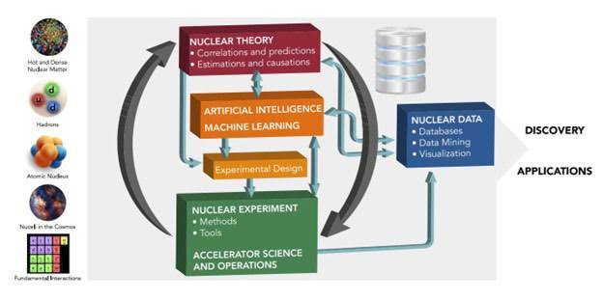Mechanism of nuclear energy generation:
Nuclear fusion, a process that powers the stars of the universe, involves smashing and fusing hydrogen, which is a common element of seawater.
Here on Earth, scientists use tokamaks — doughnut-shaped vessels surrounded by electromagnetic coils — to try to recreate the nuclear fusion reactions that occur in outer space.
The magnets in these tokamaks are used to “contain” the volatile hydrogen plasma, which is hotter than the core of the sun. Controlling the magnetic coils currently requires multiple layers of complex control systems.
Researchers at the TCV previously used 19 magnetic coils, each controlled by a separate algorithm that monitored the interior of the reactor thousands of times a second with a host of sensors. DeepMind instead created a single neural network to control all the coils at once, automatically learning which voltages needed to be supplied to them to best contain the plasma.
As well as controlling the plasma, the AI was able to shape it and move it around within the reactor. New plasma shapes may bring efficiency or stability improvements in new fusion reactors
Reinforcement learning is an AI training technique involves programming an AI to take certain actions in order to maximize its chance of earning a reward in a particular situation. In other words, the algorithm “learns” to complete a task by seeking out these preprogrammed rewards.
AI, developed on a virtual simulator, has been used around 100 times on a tokamak at the Swiss Plasma Center known as the Variable Configuration Tokamak. It controlled the magnets in the tokamak for two seconds, which is the maximum amount of time the reactor can run before it overheats.
Plasma inside the TCV fusion reactor in Switzerland:
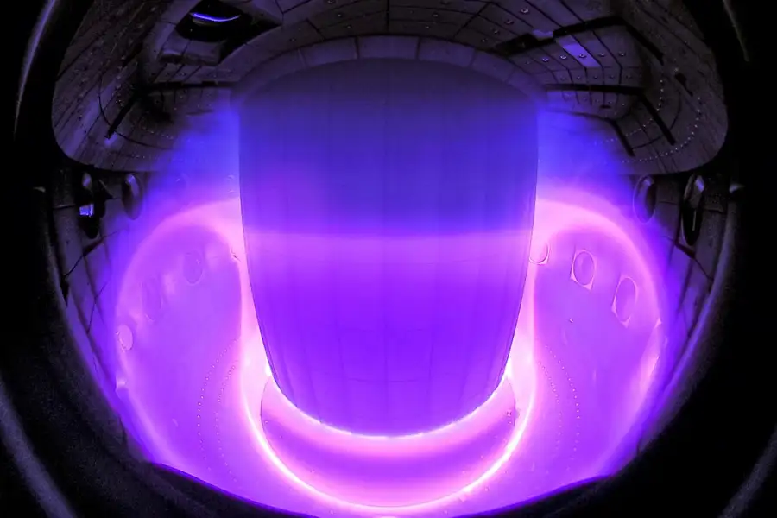

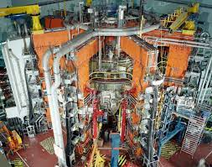
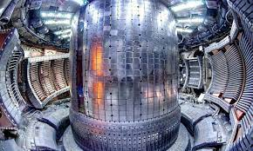
Mechanism nuclear pollution control:
AI can be utilized in nuclear pollution control mechanisms through various ways, including:

1. *Radiation Monitoring*: AI algorithms can process data from radiation sensors to detect abnormal radiation levels and trigger alerts for immediate action.

2. *Predictive Modelling*: AI can analyse historical data and predict potential nuclear pollution incidents, enabling proactive measures and better resource allocation.

3. *Robotic Cleanup*: AI-powered robots can be used to safely clean up contaminated areas, minimizing human exposure to radiation.

4. *Image Analysis*: AI can analyse satellite images and aerial photographs to identify areas affected by nuclear pollution and track changes over time.

5. *Data Fusion*: AI can integrate data from multiple sources, such as weather forecasts and pollutant dispersion models, to provide accurate real-time pollution assessments.

6. *Decision Support Systems*: AI-driven systems can assist in making informed decisions by analysing complex data sets and suggesting optimal pollution control strategies.

7. *Emergency Response*: AI can assist in coordinating emergency responses by predicting potential pollution spread, evacuations, and resource allocation.
AI can be utilized in nuclear pollution control mechanisms through various ways, including:

1. *Radiation Monitoring*: AI algorithms can process data from radiation sensors to detect abnormal radiation levels and trigger alerts for immediate action.

2. *Predictive Modeling*: AI can analyze historical data and predict potential nuclear pollution incidents, enabling proactive measures and better resource allocation.

3. *Robotic Cleanup*: AI-powered robots can be used to safely clean up contaminated areas, minimizing human exposure to radiation.

4. *Image Analysis*: AI can analyze satellite images and aerial photographs to identify areas affected by nuclear pollution and track changes over time.

5. *Data Fusion*: AI can integrate data from multiple sources, such as weather forecasts and pollutant dispersion models, to provide accurate real-time pollution assessments.

6. *Decision Support Systems*: AI-driven systems can assist in making informed decisions by analyzing complex data sets and suggesting optimal pollution control strategies.

7. *Emergency Response*: AI can assist in coordinating emergency responses by predicting potential pollution spread, evacuations, and resource allocation.

Certainly, here's a comparison table highlighting the merits and demerits of using AI in nuclear science:

| Merits of AI in Nuclear Science | Demerits of AI in Nuclear Science |
|--------------------------------------------------|--------------------------------------------------|
| Enhances reactor safety by accident prediction | Vulnerability to cyberattacks could compromise safety |
| Optimizes reactor operations for efficiency | Reduces human expertise and understanding
| Predicts and prevents potential reactor accidents| Overreliance on AI might lead to system failures |
| Simulates nuclear reactions for research | Lack of transparency in AI decision-making |
| Speeds up data analysis and pattern recognition | Ethical concerns in AI applications |

Remember that the impact of AI in nuclear science can vary depending on the specific application and context.
Sure, here's a simplified comparison table outlining nuclear energy production and pollution control with and without the integration of AI:

| Aspect | Nuclear Energy + AI | Nuclear Energy Only
| *Energy Production* | Higher efficiency and output | Consistent energy production |
| *Safety* | Enhanced safety monitoring | Standard safety protocols |
| *Waste Management* | AI-assisted waste disposal | Traditional waste management |
| *Pollution Control* | Precise emissions monitoring | Conventional pollution control |
| *Risk Assessment* | AI-based risk analysis | Conventional risk assessment |
| *Adaptability* | Real-time adjustments | Manual adjustments |
| *Labor Requirements* | Reduced human intervention | Standard human involvement |
| *Environmental Impact* | Potential reduction | Similar environmental impact |
| *Cost* | Potentially higher investment | Standard operational costs |

CONCLUSION:
In conclusion, the integration of AI in nuclear research and pollution control holds immense promise for addressing complex challenges in the nuclear industry. By enhancing data analysis, optimizing processes, and enabling predictive modeling, AI contributes to safer and more efficient operations. Additionally, AI-powered tools assist in monitoring and mitigating nuclear pollution, ensuring a more sustainable and secure future. As these technologies continue to evolve, collaborations between experts in AI and nuclear science will be vital to unlocking the full potential of AI-driven solutions in this critical field.

